PLEASE READ AND CHOOSE AN OPTION BELOW – IF YOU DO NOT CHOOSE AN OPTION, WE WILL ASSUME THAT YOU DO NOT WANT REMINDER NOTIFICATIONS FROM AVANTI THERAPY.
--------------------------------------------
As a courtesy, we have an automated notification system that will send out reminder phone calls, text messages, or emails, prior to your appointment.
By providing us with your contact information, you are giving us permission to send you reminder messages for appointments as well as periodic relevant, clinical information. If at any time you would like to opt out of this service, please notify our front desk staff.
PLEASE UNDERSTAND that these calls/texts/emails are AUTOMATED and may come with less than 24 hours until your appointment – THESE REMINDERS ARE A COURTESY. THE TIMING OF THESE CALLS WILL NOT EXCUSE THE $55 LATE CANCELLATION FEE THAT WILL INCUR if you need to cancel with less than 24 hours’ notice. Furthermore, as stated on the Avanti Therapy Policies, Monday cancellations MUST be received by 3pm the preceding Friday.

I WOULD LIKE MY REMINDERS TO BE SENT VIA (check up to two):
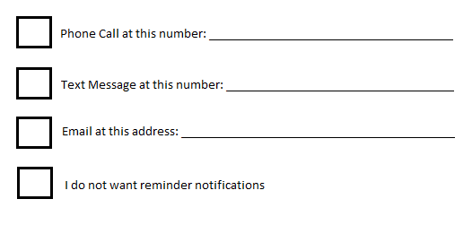
PLEASE SIGN THAT YOU HAVE READ AND UNDERSTOOD THE ABOVE: ____________________________________

